NAME : Shri Harshini Devi . A
REG.NO : 192524104
Dept. Name : CSE -AIDS
Course Code/Course Name: DSA06 /Data Handling and Visualization
Date: 16/07/2026

LIST OF EXPERIMENTS

Set 7 Customer Demographics Analysis
Dataset: Customer Demographics

1. Create a bar chart to visualize the distribution of customer ages. Label the axes and title the chart.

# Customer Age Data
age <- c(28, 35, 42)

# Customer IDs
customer <- c("Customer 1", "Customer 2", "Customer 3")

# Create Bar Chart
barplot(age,
names.arg = customer,
main = "Distribution of Customer Ages",
xlab = "Customers",
ylab = "Age (Years)",
col = "skyblue",
border = "black")
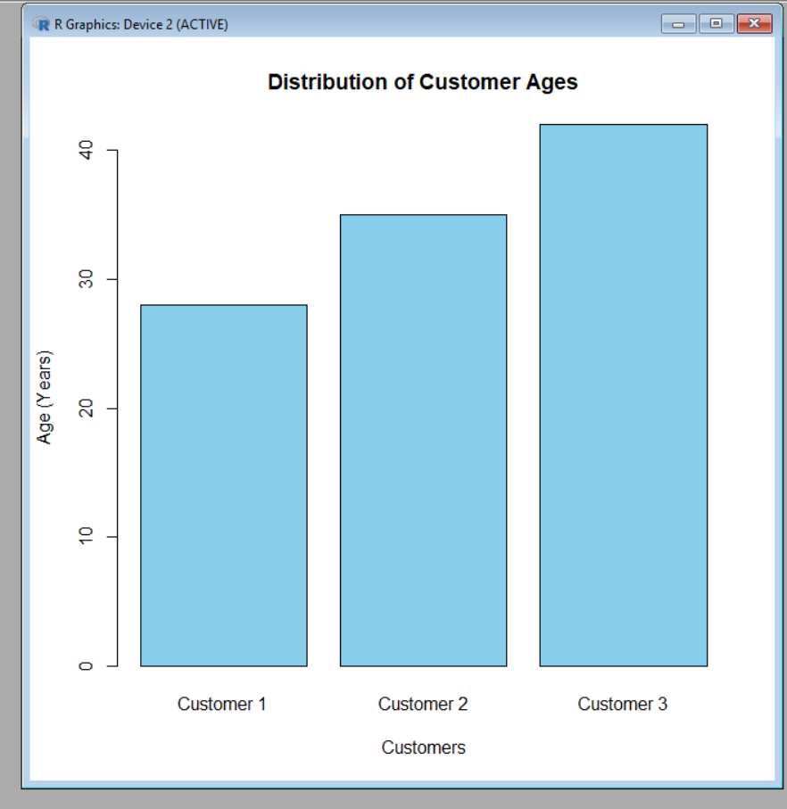

2. Generate a pie chart to represent the distribution of customers by gender.

# Customer Gender Data
gender <- c("Female", "Male", "Female")

# Count the number of customers by gender
gender_count <- table(gender)

# Create Pie Chart
pie(gender_count,
labels = names(gender_count),
main = "Distribution of Customers by Gender",
col = c("pink", "lightblue"))

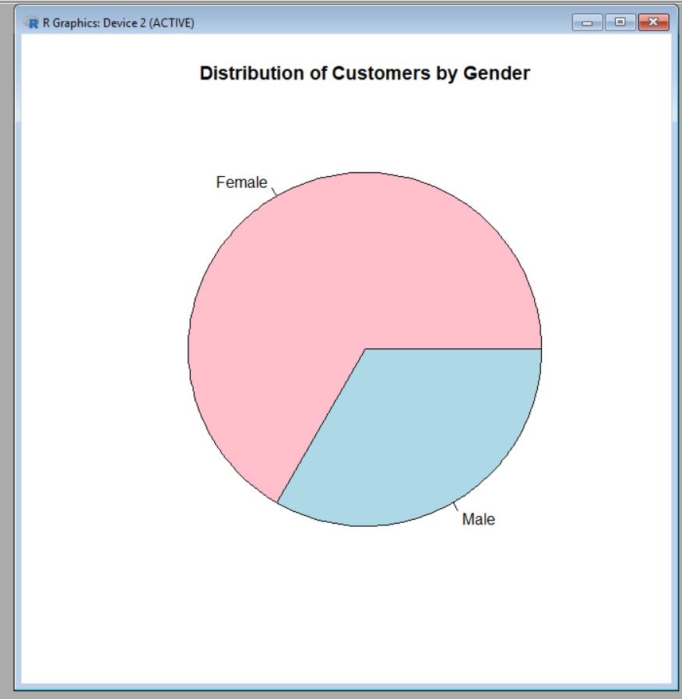

3. Build a table to show the demographic information for each customer. Label the table elements.

# Customer Demographics Data
customer_data <- data.frame(
Customer_ID = c(1, 2, 3),
Age = c(28, 35, 42),
Gender = c("Female", "Male", "Female"),
Income = c(50000, 60000, 75000)
)

# Display Table
print("Customer Demographics Table")
print(customer_data)

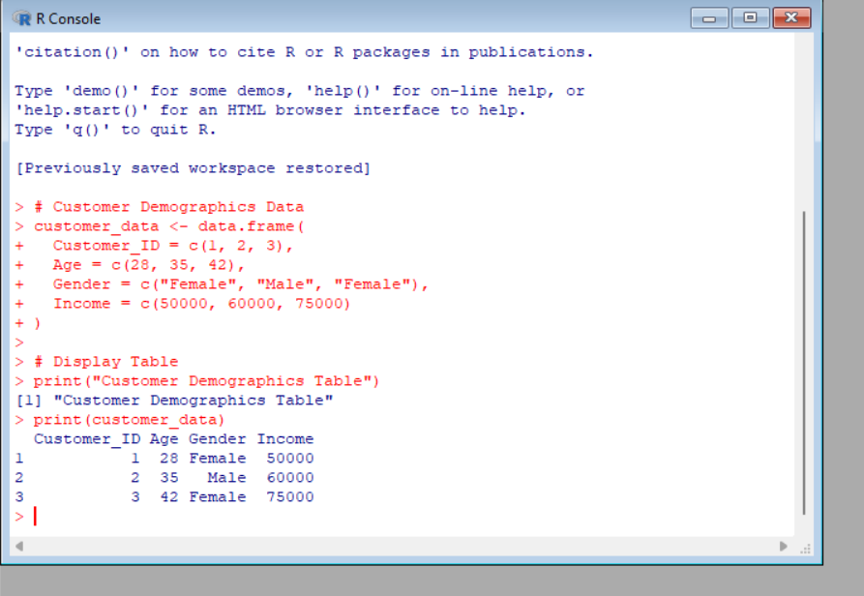

4. Develop a Tableau dashboard combining the bar chart, pie chart, and the table for interactive exploration of customer demographics.

Steps to Create the Dashboard
- Open Tableau Desktop.
- Import the Customer Demographics dataset (Excel/CSV).
Sheet 1: Bar Chart
- Drag Customer ID (or Customer Name) to Columns.
- Drag Age to Rows.
- Select Bar from the Marks card.
- Add the title "Customer Age Distribution".
Sheet 2: Pie Chart
- Drag Gender to Color.
- Drag Gender to Label.
- Drag Number of Records to Angle.
- Select Pie from the Marks card.
- Add the title "Customer Distribution by Gender".
Sheet 3: Customer Demographics Table
- Create a new worksheet.
- Drag Customer ID to Rows.
- Drag Age, Gender, and Income to Text.
- Add the title "Customer Demographics Table".
Create the Dashboard
- Click Dashboard → New Dashboard.
- Drag the Bar Chart, Pie Chart, and Customer Demographics Table onto the dashboard.
- Arrange them neatly for easy viewing.
Make the Dashboard Interactive
- Click Dashboard → Actions → Add Action → Filter.
- Set any chart as the Source and the remaining charts/table as the Target.
- Choose Run action on Select.
- Clicking on a bar or pie slice will filter and update the other visualizations.
Dashboard Features
- 📊 Bar Chart showing customer age distribution.
- 🥧 Pie Chart showing gender distribution.
- 📋 Table displaying customer demographic details.
- 🔍 Interactive filtering and highlighting for easy exploration of customer demographics.

Set 8 Employee Performance Analysis
Dataset: Employee Performance

1. Create a line chart to visualize the performance trend of employees over time. Label the axes and
title the chart.

# Employee Data
employee <- c(1, 2, 3)
performance <- c(85, 92, 78)

# Create Line Chart
plot(employee, performance,
type = "o",
col = "blue",
pch = 16,
lwd = 2,
main = "Employee Performance Trend",
xlab = "Employee ID",
ylab = "Performance Score")

# Add Legend
legend("topright",
legend = "Performance Score",
col = "blue",
lty = 1,
pch = 16)

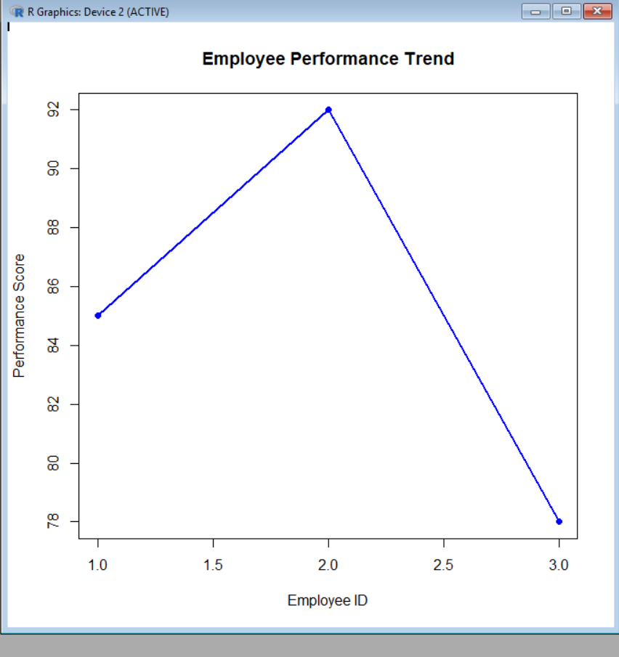

2. Generate a bar chart showing the distribution of employees across different departments. Label the chart elements.

# Employee Department Data
department <- c("Sales", "HR", "Marketing")

# Count Employees in Each Department
dept_count <- table(department)

# Create Bar Chart
barplot(dept_count,
main = "Employee Distribution by Department",
xlab = "Department",
ylab = "Number of Employees",
col = c("skyblue", "lightgreen", "orange"),
border = "black")

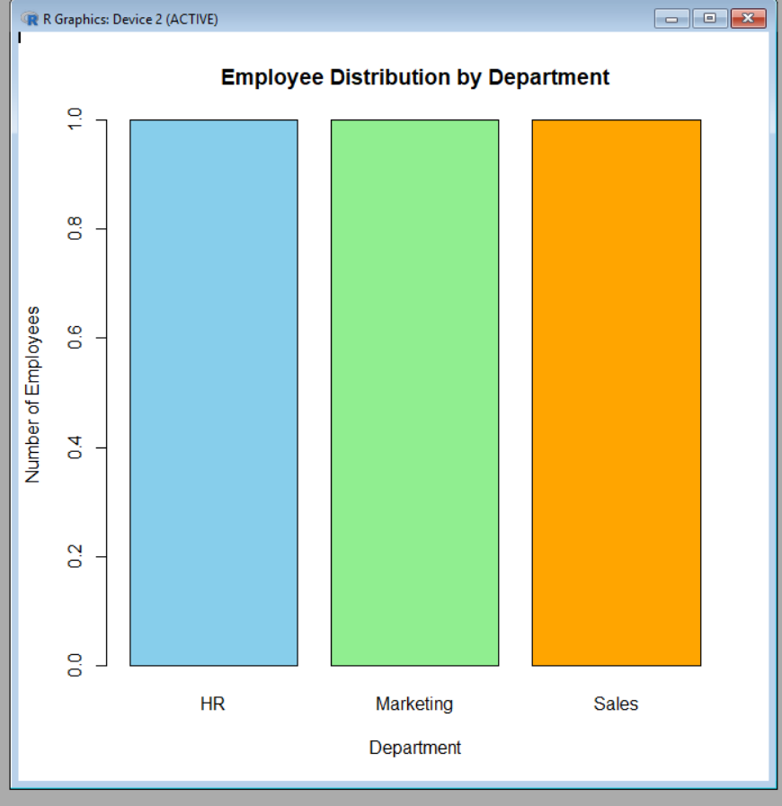

3.Build a table to display the performance data for each employee. Label the table elements.
# Employee Performance Data
employee_data <- data.frame(
Employee_ID = c(1, 2, 3),
Department = c("Sales", "HR", "Marketing"),
Years_of_Service = c(5, 3, 7),
Performance_Score = c(85, 92, 78)
)

# Display Table
print("Employee Performance Table")
print(employee_data)

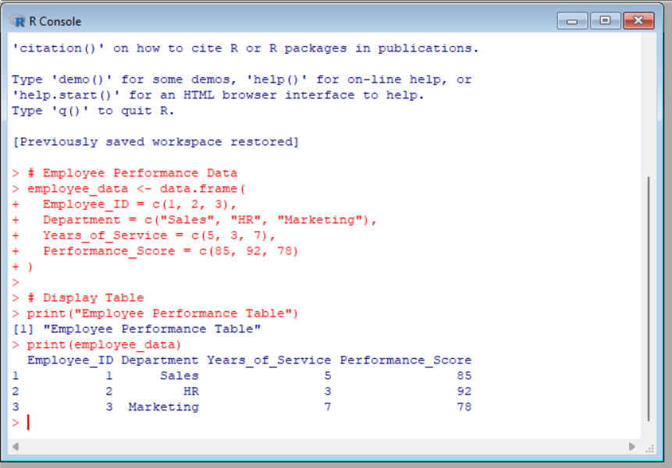

4. Develop a Tableau dashboard combining the line chart, bar chart, and the table for interactive exploration of employee performance data.

Steps to Create the Dashboard
- Open Tableau Desktop.
- Import the Employee Performance dataset (Excel/CSV).
Sheet 1: Line Chart
- Drag Employee ID to Columns.
- Drag Performance Score to Rows.
- Select Line from the Marks card.
- Add the title "Employee Performance Trend".
Sheet 2: Bar Chart
- Drag Department to Columns.
- Drag Number of Records (or COUNT(Employee ID)) to Rows.
- Select Bar from the Marks card.
- Add the title "Employee Distribution by Department".
Sheet 3: Employee Performance Table
- Create a new worksheet.
- Drag Employee ID to Rows.
- Drag Department, Years of Service, and Performance Score to Text.
- Add the title "Employee Performance Table".
Create the Dashboard
- Click Dashboard → New Dashboard.
- Drag the Line Chart, Bar Chart, and Employee Performance Table onto the dashboard.
- Arrange them neatly for easy viewing.
Make the Dashboard Interactive
- Click Dashboard → Actions → Add Action → Filter.
- Set one visualization as the Source and the remaining visualizations as the Target.
- Choose Run action on Select.
- Clicking on an employee or department in one visualization will automatically filter and update the others.
Dashboard Features
- 📈 Line Chart showing employee performance trend.
- 📊 Bar Chart showing employee distribution by department.
- 📋 Table displaying employee performance details.
- 🔍 Interactive filtering, highlighting, and comparison of employee performance data.

set 9
Dataset: Online_Learning_Activity.csv

1. Import the dataset in R. Plot a histogram for Quiz_Score. Draw a boxplot of Quiz_Score by Course. Add title and labels. Interpret student performance.
# Create the dataset
student_data <- data.frame(
Student_ID = c("L01","L02","L03","L04","L05","L06"),
Gender = c("Male","Female","Male","Female","Male","Female"),
Age = c(20,22,19,21,23,20),
Course = c("R","R","SQL","R","R","SQL"),
Study_Time = c(3.5,4.2,2.0,5.0,2.5,4.0),
Videos_Watched = c(12,15,8,18,9,14),
Quiz_Score = c(78,85,65,92,70,88),
Login_Date = as.Date(c("2025-01-05","2025-01-05",
"2025-02-08","2025-02-08",
"2025-03-12","2025-03-12"))
)

# Histogram
hist(student_data$Quiz_Score,
main = "Histogram of Quiz Scores",
xlab = "Quiz Score",
ylab = "Frequency",
col = "skyblue",
border = "black")

# Boxplot
boxplot(Quiz_Score ~ Course,
data = student_data,
main = "Quiz Score by Course",
xlab = "Course",
ylab = "Quiz Score",
col = c("lightgreen", "orange"))
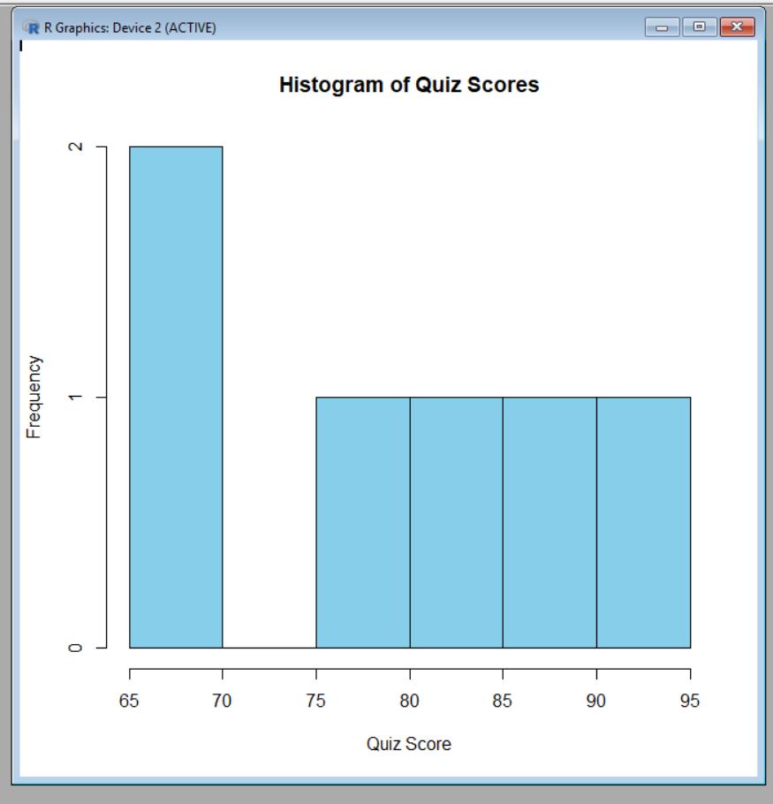

2. Create a scatter plot using R programming between Study_Time and Quiz_Score. Represent Videos_Watched using bubble size. Apply transparency. Explain the learning pattern.

# Create the dataset
student_data <- data.frame(
Student_ID = c("L01","L02","L03","L04","L05","L06"),
Gender = c("Male","Female","Male","Female","Male","Female"),
Age = c(20,22,19,21,23,20),
Course = c("R","R","SQL","R","R","SQL"),
Study_Time = c(3.5,4.2,2.0,5.0,2.5,4.0),
Videos_Watched = c(12,15,8,18,9,14),
Quiz_Score = c(78,85,65,92,70,88)
)

# Bubble Scatter Plot
plot(student_data$Study_Time,
student_data$Quiz_Score,
cex = student_data$Videos_Watched/5,
pch = 16,
col = rgb(0, 0, 1, 0.5),
main = "Study Time vs Quiz Score",
xlab = "Study Time (Hours)",
ylab = "Quiz Score")

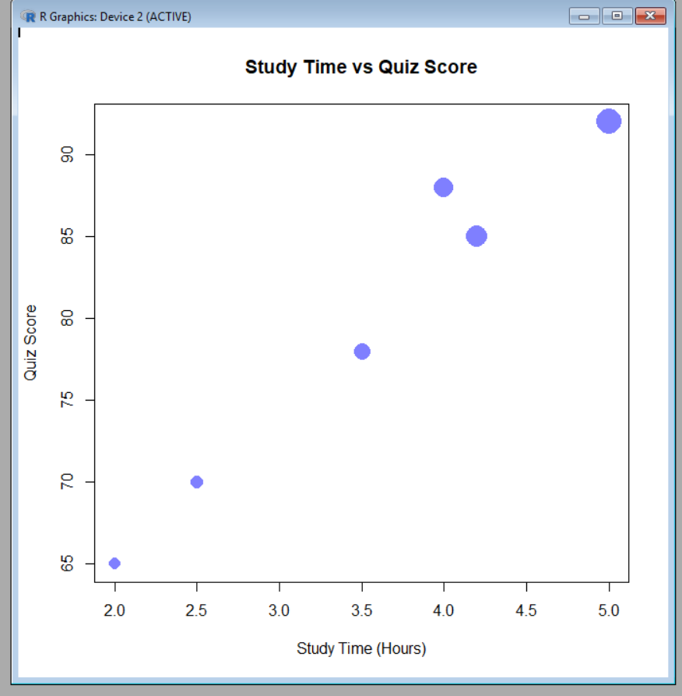

3. Using R programming, convert Login_Date into Date format. Calculate average quiz score per month. Plot a line chart. Apply moving average smoothing. Identify the trend.

# Create the dataset
student_data <- data.frame(
Student_ID = c("L01","L02","L03","L04","L05","L06"),
Gender = c("Male","Female","Male","Female","Male","Female"),
Age = c(20,22,19,21,23,20),
Course = c("R","R","SQL","R","R","SQL"),
Study_Time = c(3.5,4.2,2.0,5.0,2.5,4.0),
Videos_Watched = c(12,15,8,18,9,14),
Quiz_Score = c(78,85,65,92,70,88),
Login_Date = c("2025-01-05","2025-01-05",
"2025-02-08","2025-02-08",
"2025-03-12","2025-03-12")
)

# Convert Login_Date to Date format
student_data$Login_Date <- as.Date(student_data$Login_Date)

# Extract Month
month <- format(student_data$Login_Date, "%Y-%m")

# Calculate Average Quiz Score per Month
avg_score <- tapply(student_data$Quiz_Score, month, mean)

# Plot Line Chart
plot(avg_score,
type = "o",
col = "blue",
pch = 16,
xlab = "Month",
ylab = "Average Quiz Score",
main = "Average Monthly Quiz Score")

# Moving Average (2-point)
ma <- filter(avg_score, rep(1/2, 2), sides = 1)

# Add Moving Average Line
lines(ma, col = "red", lwd = 2)

# Legend
legend("topleft",
legend = c("Average Score", "Moving Average"),
col = c("blue", "red"),
lty = 1,
pch = 16)

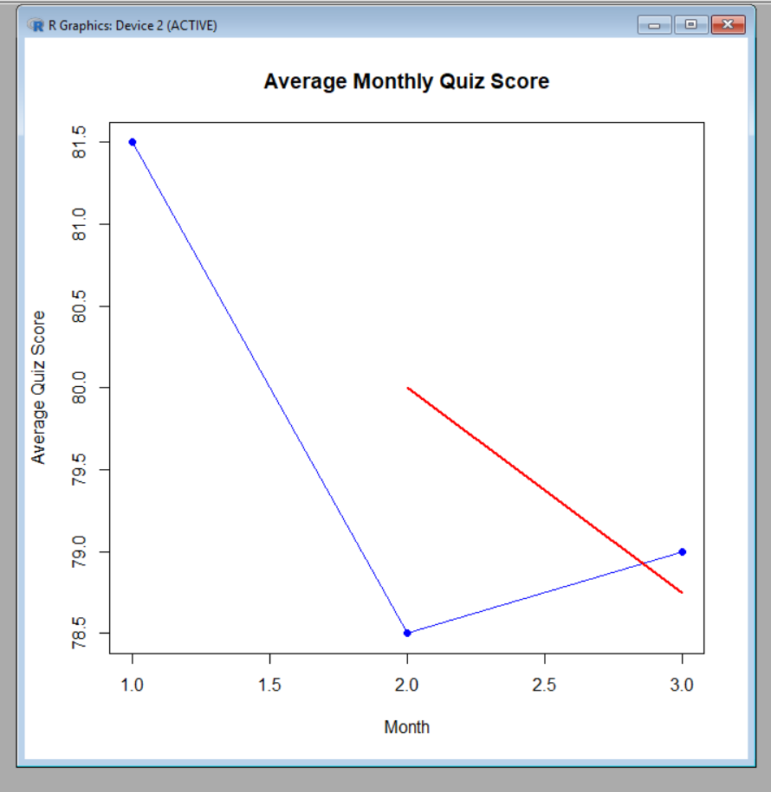

4. Import Online_Learning_Activity.csv into Tableau. Create a bar chart showing average quiz score by Course. Create a scatter plot (Study Time vs Quiz Score). Add filter for Gender and Course. Design a mini interactive dashboard.

Steps to Create the Dashboard
- Open Tableau Desktop.
- Import the Online_Learning_Activity.csv dataset (or create the dataset in Excel and save it as CSV if your question paper only provides the data).
Sheet 1: Bar Chart (Average Quiz Score by Course)
- Drag Course to Columns.
- Drag Quiz_Score to Rows.
- Click the drop-down on SUM(Quiz_Score) and change it to Average (AVG).
- Select Bar from the Marks card.
- Add the title "Average Quiz Score by Course".
Sheet 2: Scatter Plot (Study Time vs Quiz Score)
- Drag Study_Time (hrs) to Columns.
- Drag Quiz_Score to Rows.
- Select Circle from the Marks card.
- (Optional) Drag Videos_Watched to Size to vary the bubble size.
- Add the title "Study Time vs Quiz Score".
Add Filters
- Drag Gender to the Filters shelf and choose Show Filter.
- Drag Course to the Filters shelf and choose Show Filter.
Create the Dashboard
- Click Dashboard → New Dashboard.
- Drag the Bar Chart and Scatter Plot onto the dashboard.
- Place the Gender and Course filter cards on the side of the dashboard.
Make the Dashboard Interactive
- Click Dashboard → Actions → Add Action → Filter.
- Select the charts as both Source and Target.
- Choose Run action on Select.
- Clicking a course in the bar chart filters the scatter plot, and the Gender and Course filters update both charts.
Dashboard Features
- 📊 Bar Chart showing the Average Quiz Score by Course.
- 🔵 Scatter Plot showing Study Time vs Quiz Score.
- 🎛️ Interactive Gender and Course filters.
- 🔍 Users can interactively explore student learning patterns and compare performance across different courses and genders.

Set 10 Survey Responses Analysis
Dataset: Survey Response0073

1. Create a grouped bar chart to visualize the distribution of answers for Question 1. Label the chart elements.

# Create the dataset
survey_data <- data.frame(
Survey_ID = c(1, 2, 3),
Question1 = c("A", "B", "C"),
Question2 = c("B", "A", "A"),
Question3 = c("C", "D", "B")
)

# Count responses for Question 1
q1_count <- table(survey_data$Question1)

# Create Grouped Bar Chart
barplot(q1_count,
beside = TRUE,
main = "Distribution of Answers for Question 1",
xlab = "Answer Options",
ylab = "Number of Responses",
col = c("skyblue", "lightgreen", "orange"),
border = "black")

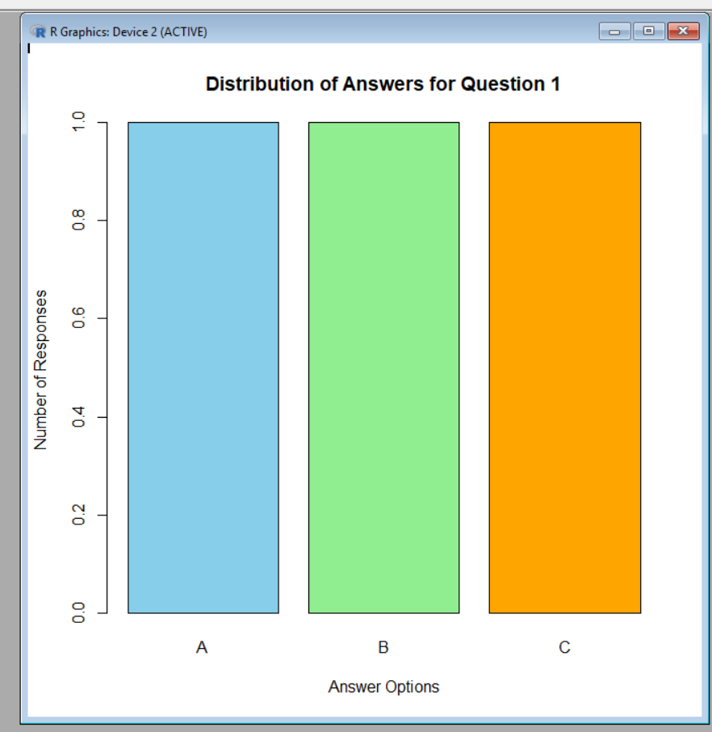

2. Generate a stacked bar chart to represent the overall distribution of responses for all three questions.

# Create dataset
survey <- data.frame(
Survey_ID = c(1, 2, 3),
Question1 = c("A", "B", "C"),
Question2 = c("B", "A", "A"),
Question3 = c("C", "D", "B")
)

# Load library
library(ggplot2)
library(tidyr)
library(dplyr)

# Convert data from wide format to long format
survey_long <- survey %>%
pivot_longer(
cols = Question1:Question3,
names_to = "Question",
values_to = "Response"
)

# Count responses
response_count <- survey_long %>%
group_by(Question, Response) %>%
summarise(Count = n())

# Create stacked bar chart
ggplot(response_count, aes(x = Question, y = Count, fill = Response)) +
geom_bar(stat = "identity") +
labs(
title = "Overall Distribution of Survey Responses Across All Questions",
x = "Questions",
y = "Number of Responses",
fill = "Response Options"
) +
theme_minimal()

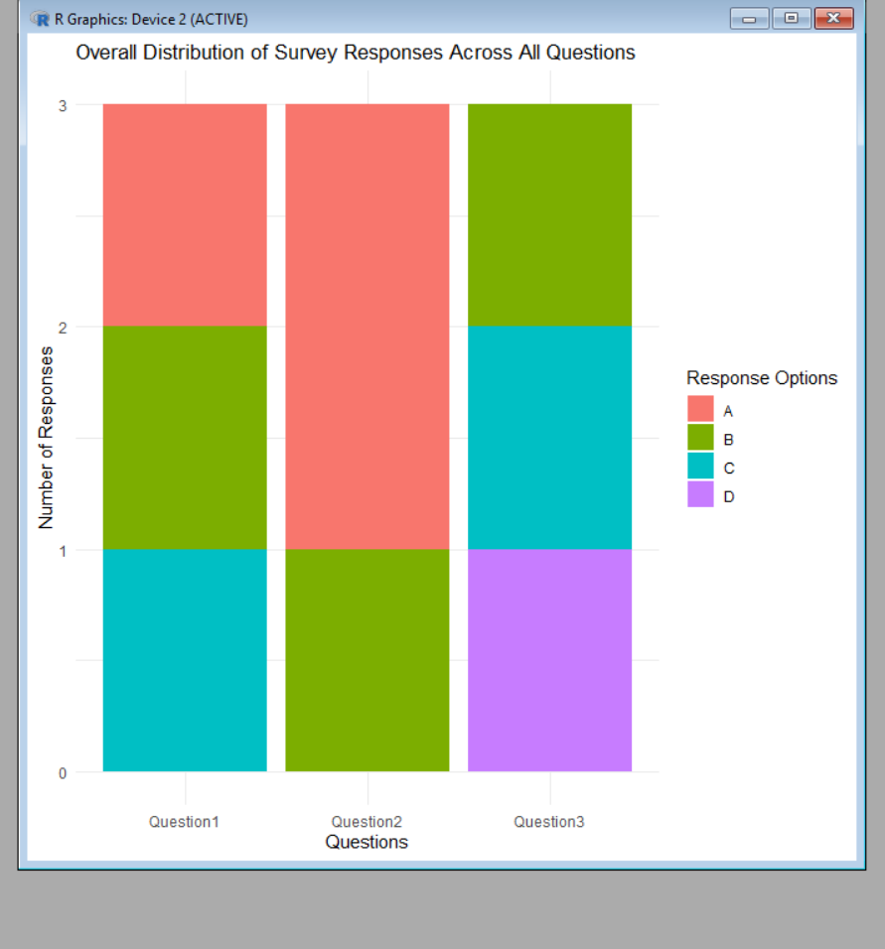

- Build a table to show the survey response data for each survey. Label the table elements.
# Create survey response dataset
survey <- data.frame(
Survey_ID = c(1, 2, 3),
Question_1 = c("A", "B", "C"),
Question_2 = c("B", "A", "A"),
Question_3 = c("C", "D", "B")
)

# Display table
print(survey)

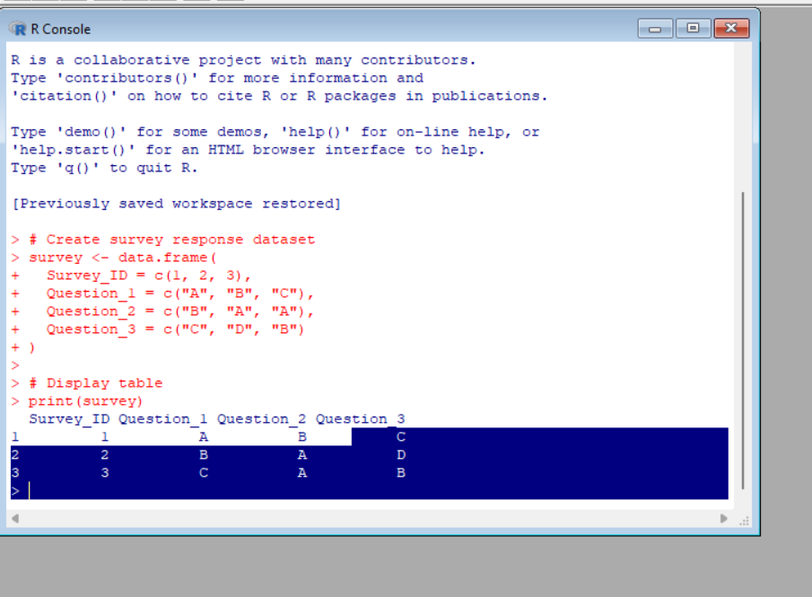

4. Develop a Tableau dashboard combining the grouped bar chart, stacked bar chart, and the table for interactive exploration of survey responses.

Steps to Create Dashboard in Tableau:
- Import Dataset
  - Open Tableau Desktop.
  - Connect to the Survey Responses dataset.
- Create Worksheets
Worksheet 1: Grouped Bar Chart
- Drag Question 1 to Columns.
- Drag Survey ID to Rows and select Count.
- Select Bar Chart.
- Add Question 1 to Color.
- Title: "Distribution of Answers for Question 1"
Worksheet 2: Stacked Bar Chart
- Convert Question columns into rows using Pivot.
- Drag Question to Columns.
- Drag Response to Color.
- Drag Response to Rows and select Count.
- Select Stacked Bar Chart.
- Title: "Overall Distribution of Responses Across Questions"
Worksheet 3: Survey Response Table
- Drag Survey ID, Question 1, Question 2, and Question 3 into Rows.
- Select Text Table.
- Title: "Survey Response Details"

Creating the Dashboard:
- Click New Dashboard.
- Set dashboard size (e.g., Automatic).
- Drag the three worksheets into the dashboard:
  - Grouped Bar Chart
  - Stacked Bar Chart
  - Survey Response Table
- Arrange the layout:
  - Top: Grouped Bar Chart
  - Middle: Stacked Bar Chart
  - Bottom: Survey Response Table

Add Interactivity:
Filters:
- Add Survey ID as a filter to allow users to view individual survey responses.
Actions:
- Go to Dashboard → Actions → Add Action → Filter.
- Select the grouped bar chart as the source.
- Allow selection of a response option to update the stacked chart and table.

Dashboard Title:
"Survey Responses Analysis Dashboard"
Dashboard Components:
Component | Purpose
Grouped Bar Chart | Shows distribution of answers for Question 1
Stacked Bar Chart | Compares response patterns across all questions
Table | Displays individual survey responses
Insight:
The interactive dashboard enables users to analyze response patterns, compare question-wise distributions, and view detailed survey records efficiently. 📊📋

Set 11
Product Category Analysis
Dataset: Product Categories

1.Generate a funnel chart to analyze the sales conversion process for each product category. Label the
stages and title the chart.

# Create dataset
sales <- data.frame(
Category = c("Electronics", "Clothing", "Appliances"),
Sales = c(50000, 35000, 40000)
)

# Sort data in descending order
sales <- sales[order(-sales$Sales), ]

# Install and load package
library(ggplot2)

# Create funnel chart
ggplot(sales, aes(x = reorder(Category, Sales), y = Sales, fill = Category)) +
geom_bar(stat = "identity", width = 1) +
coord_flip() +
labs(
title = "Product Category Sales Funnel Chart",
x = "Sales Conversion Stages",
y = "Sales Amount ($)",
fill = "Product Category"
) +
theme_minimal()

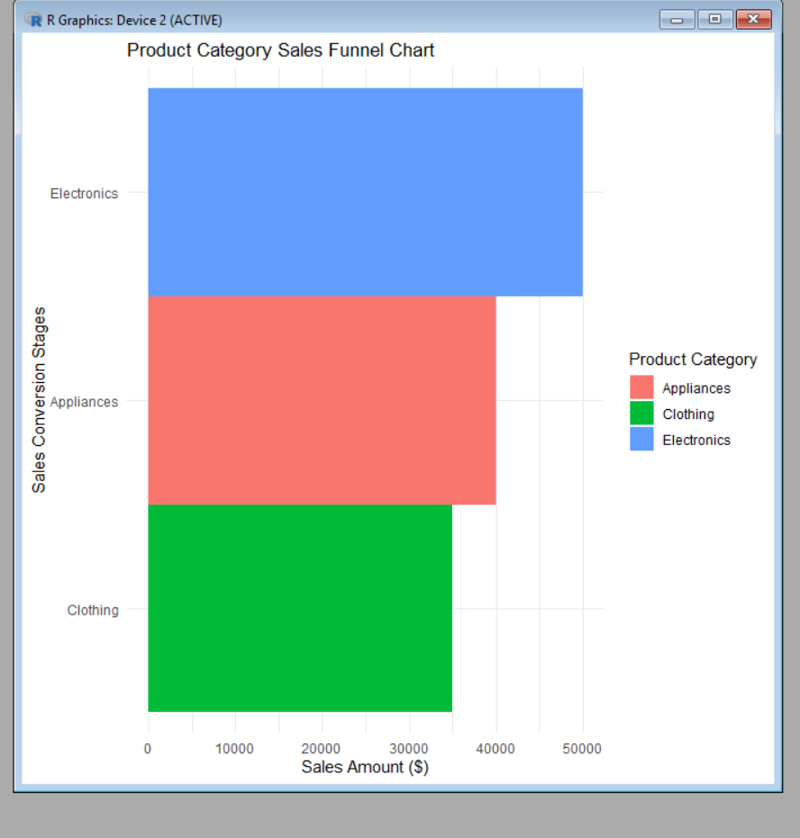

- Build a table to display the sales data for each product category. Label the table elements.
# Create dataset
product_sales <- data.frame(
Category = c("Electronics", "Clothing", "Appliances"),
Sales = c(50000, 35000, 40000)
)

# Display table
print(product_sales)

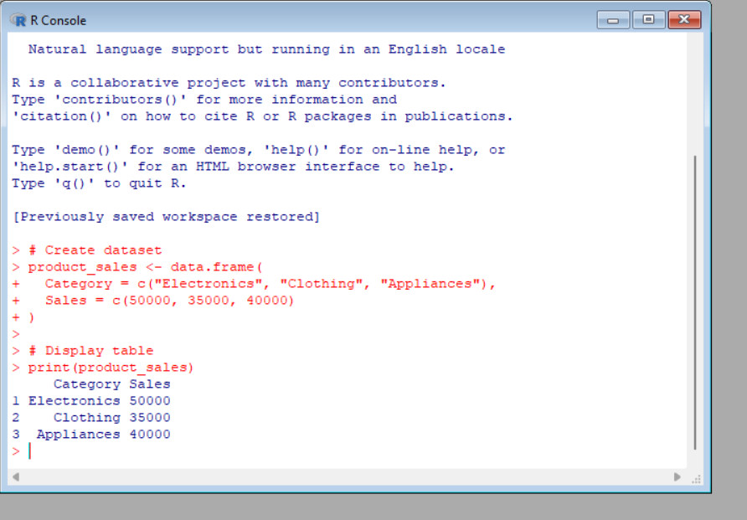

3. Develop a Tableau dashboard combining the pie chart, funnel chart, and the table for interactive
exploration of product category data.

Dataset: Product Categories
Category | Sales (in $)
Electronics | 50000
Clothing | 35000
Appliances | 40000

Steps to Create Dashboard in Tableau:
1. Create Worksheets
Worksheet 1: Pie Chart (Sales Distribution)
Steps:
- Import the Product Categories dataset into Tableau.
- Drag Category to the Color shelf.
- Drag Sales to the Angle shelf.
- Select Pie Chart from the visualization options.
- Drag Sales to Label to display values.
Chart Title:
"Sales Distribution by Product Category"
Purpose:
Shows the percentage contribution of each product category to total sales.

Worksheet 2: Funnel Chart (Sales Conversion Analysis)
Steps:
- Drag Category to Rows.
- Drag Sales to Columns.
- Sort sales values in descending order.
- Select Bar Chart and convert it into a funnel-style visualization.
- Add Category and Sales values as labels.
Chart Title:
"Product Category Sales Funnel"
Stages:
- Electronics – $50,000
- Appliances – $40,000
- Clothing – $35,000
Purpose:
Displays sales ranking and performance comparison among categories.

Worksheet 3: Sales Data Table
Steps:
- Drag Category to Rows.
- Drag Sales to Text.
- Select Text Table.
Chart Title:
"Product Category Sales Details"

Creating the Tableau Dashboard
- Click New Dashboard.
- Set dashboard size to Automatic.
- Drag the following sheets into the dashboard:
  - Pie Chart
  - Funnel Chart
  - Sales Data Table
Suggested Layout:
------------------------------------------------
| Product Category Analysis Dashboard |
------------------------------------------------
| Pie Chart | Funnel Chart |
| Sales Distribution | Sales Ranking |
------------------------------------------------
| Product Sales Data Table |
------------------------------------------------

Add Interactivity:
Filters:
- Add Category as a filter.
- Users can select a category to update all charts.
Dashboard Actions:
- Go to Dashboard → Actions → Add Action → Filter.
- Select Pie Chart as the source.
- Apply the selection to Funnel Chart and Table.

Dashboard Title:
"Product Category Sales Analysis Dashboard"
Insights:
- Electronics contributes the highest sales share ($50,000).
- Appliances shows moderate sales performance ($40,000).
- Clothing has the lowest sales contribution ($35,000).
- The interactive dashboard allows users to compare sales visually and explore category-wise performance. 📊📈
- Create a pie chart to represent the distribution of sales across product categories. Include labels.
# Create dataset
product_sales <- data.frame(
Category = c("Electronics", "Clothing", "Appliances"),
Sales = c(50000, 35000, 40000)
)

# Load library
library(ggplot2)

# Create pie chart
ggplot(product_sales, aes(x = "", y = Sales, fill = Category)) +
geom_bar(stat = "identity", width = 1) +
coord_polar("y") +
labs(
title = "Sales Distribution Across Product Categories",
fill = "Product Category"
) +
theme_void()
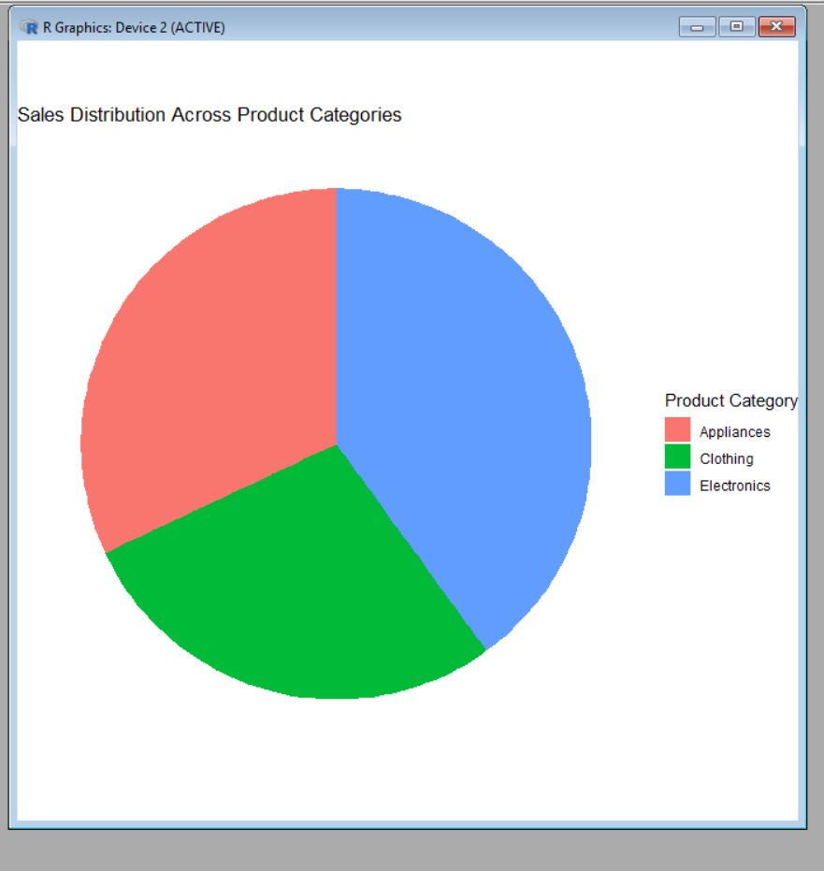

Set 12 :Dataset: Website Traffic
1. Create a line chart to visualize the trend in daily page views over time. Label the axes and title the
chart.

# Website Traffic Dataset
Date <- as.Date(c("2023-01-01", "2023-01-02", "2023-01-03"))
PageViews <- c(1500, 1600, 1400)

# Create Line Chart
plot(Date, PageViews,
type = "o",
col = "blue",
pch = 16,
lwd = 2,
xlab = "Date",
ylab = "Page Views",
main = "Daily Page Views Over Time")

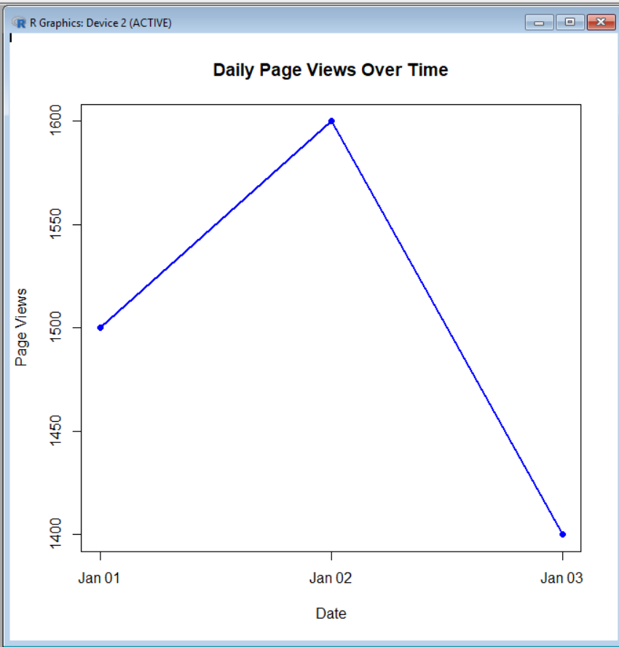

2. Generate a bar chart showing the top N days with the highest click-through rates. Label the chart
elements.

# Website Traffic Dataset
Date <- c("2023-01-01", "2023-01-02", "2023-01-03")
CTR <- c(2.3, 2.7, 2.0)

# Sort data in descending order of Click-through Rate
data <- data.frame(Date, CTR)
data <- data[order(data$CTR, decreasing = TRUE), ]

# Select Top N days (here N = 3)
topN <- head(data, 3)

# Create Bar Chart
barplot(topN$CTR,
names.arg = topN$Date,
col = "skyblue",
xlab = "Date",
ylab = "Click-through Rate (%)",
main = "Top 3 Days with Highest Click-through Rates")

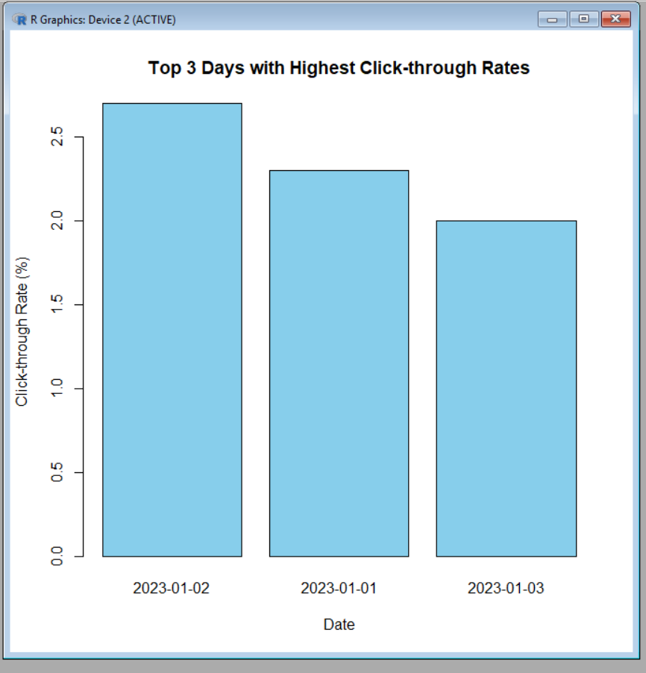

3.Build a table to show the website traffic data for each day. Label the table elements.
# Website Traffic Dataset
Date <- c("2023-01-01", "2023-01-02", "2023-01-03")
PageViews <- c(1500, 1600, 1400)
CTR <- c("2.3%", "2.7%", "2.0%")

# Create Table
website_data <- data.frame(
Date = Date,
Page_Views = PageViews,
Click_Through_Rate = CTR
)

# Display Table
print(website_data)

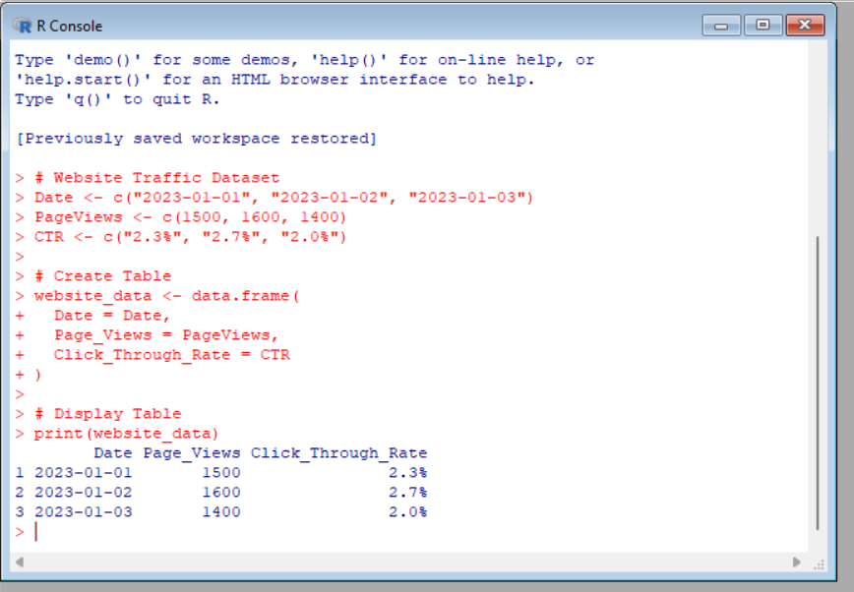

4. Develop a Tableau dashboard combining the line chart, bar chart, and the table for interactive
exploration of website traffic data. 4. Develop a Tableau dashboard combining the line chart, bar chart, and the table for interactive
exploration of website traffic data.

Tableau Dashboard: Website Traffic Data
Follow these steps to create an interactive Tableau dashboard combining the Line Chart, Bar Chart, and Table.
- Import Data
  - Open Tableau.
  - Connect to the Website Traffic dataset (CSV/Excel).
- Create Worksheet 1 – Line Chart
  - Drag Date → Columns.
  - Drag Page Views → Rows.
  - Set Marks to Line.
  - Title: Daily Page Views Over Time.
- Create Worksheet 2 – Bar Chart
  - Drag Date → Columns.
  - Drag Click-through Rate → Rows.
  - Set Marks to Bar.
  - Sort in Descending order by Click-through Rate.
  - Title: Top Days by Click-through Rate.
- Create Worksheet 3 – Table
  - Drag Date, Page Views, and Click-through Rate to the Text shelf.
  - Title: Website Traffic Data.
- Build Dashboard
  - Click New Dashboard.
  - Drag the Line Chart, Bar Chart, and Table onto the dashboard.
  - Arrange them neatly (e.g., line chart on top, bar chart and table below).
- Add Interactivity
  - Go to Dashboard → Actions → Add Action → Filter.
  - Set the Line Chart and Bar Chart as source sheets.
  - Apply the filter to all sheets.
  - Show filters for Date if required.
Final Dashboard Layout
---------------------------------------------------------
| Daily Page Views Over Time (Line Chart) |
---------------------------------------------------------
| Top Days by CTR (Bar Chart) | Website Traffic Table |
---------------------------------------------------------
Dashboard Features
- Line Chart: Shows the trend of daily page views.
- Bar Chart: Displays days with the highest click-through rates.
- Table: Lists Date, Page Views, and Click-through Rate.
- Interactive Filter: Selecting a day in one chart highlights and filters the related data in the other charts and the table.

